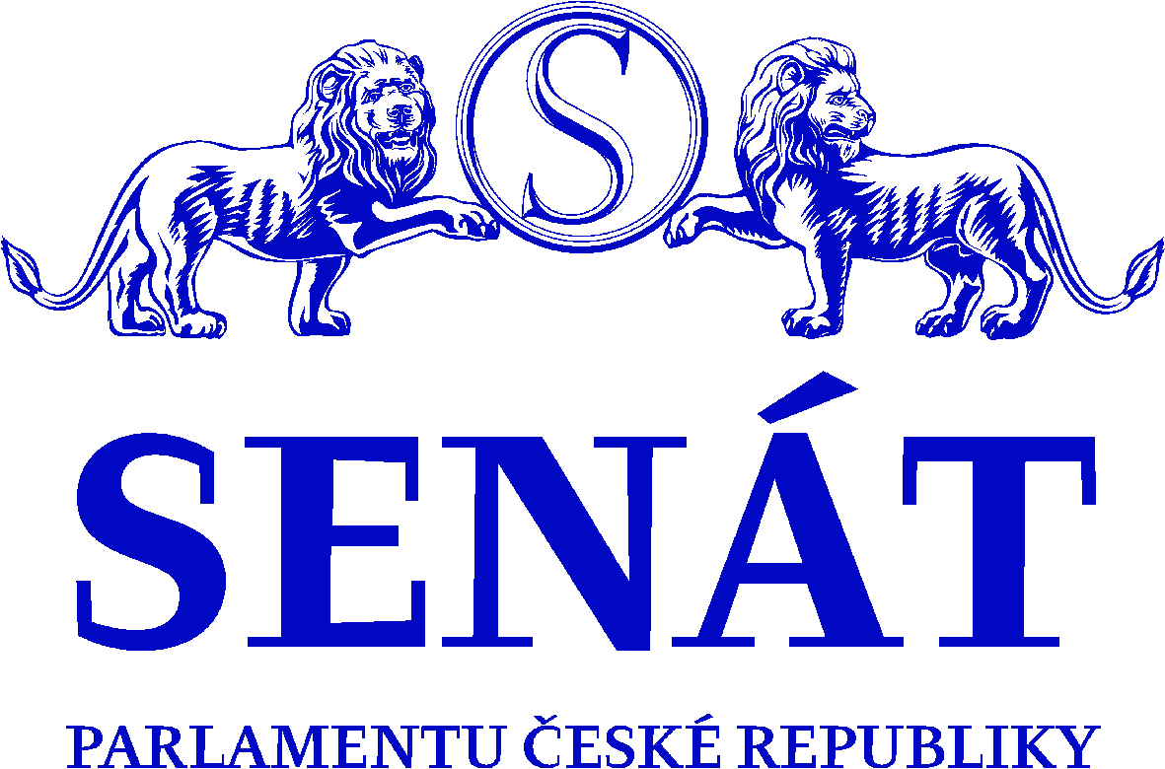
PARLAMENT ČESKÉ REPUBLIKY
S E N Á T
Jan Horník
Místopředseda Senátu

Zbyněk Linhart
Předseda Výboru pro územní rozvoj, veřejnou správu a životní prostředí
Senátu Parlamentu České republiky

Prague, July 14, 2021

Dear Madam President,

the objective of cohesion policy is to help less developed regions reduce economic, social, and territorial inequalities.

This is a theory that applies to many areas. Unfortunately, not in case of the NUTS II region of the Northwest of the Czech Republic. The cohesion policy is failing fatally in this region. The cohesion help is being pretended here for over thirty years already, but in fact exactly the opposite is taking place. It is an anti-cohesion of some kind making it possible for the rich to achieve even better prosperity while the poor keep getting even poorer. Unfortunately, the Northwest, as a depreciated region since World War II, is being treated similarly with the Just Transformation Fund (JST), the Modernisation Fund (MF), or the National Recovery and Resilience Plan (NRRP). For details see below.

Madam President, if the government and the officials of the Czech Republic, who repeatedly do not redistribute and allocate available EU funds based on cohesion principles, are failing, unfortunately, the European Commission being a super-visor, is failing too as it ignores and tolerates this way of dealing with European taxpayer funds in the Czech Republic in the long term.

Attached to this letter you will find a summary presentation on the decimated Northwest region. Please allow me to briefly frame the selected chapters of the presentation in view of the data and indicators that are rather self-explanatory:

- Wealthy Sudetenland becomes the poorest region of the Czech Republic
The North-western border region of Sudetenland, and once the multinational region of the Czech Republic, represented one of Europe's most industrialised and developed regions at the beginning of the last century. The decline of this region started after the war and the rather abrupt displacement of the original inhabitants of the region. This decline never stopped and continues to this day. While a dynamic development has been kick-started in the rest of the Sudetenland, there has been no transformation in the Northwest and the region has gradually become the most affected area in the Czech Republic, with the highest concentration of poverty, extremism and negative sociopathology.

- Concentrated decline of the region with 1,5 million inhabitants
When it comes to GDP per capita compared to the average of the Czech Republic, the Northwest region has already fallen below 70% in 30 years of decline, down from around 95% despite the claimed support!
When it comes to GDP per capita compared to the EU average, it would perhaps be better to introduce 4 levels of cohesion regions:

1) Prague, which is twice the EU average
2) The Southeast, Central Bohemia and Southwest, which hover around 80% of the EU average
3) The Northeast, Central Moravia, and Moravia-Silesia, which reach about 75% of the EU average
4) The Northwest, which has not been converging with its 64% since 2007!

And it is these four levels on which the EU should build on its cohesion policy in the long term.

Yet the decline of the Northwest affects all areas, not only economic, but also cultural, social, health, educational, whether one looks at almost any phenomenon or region, the Northwest reports the worst indicators, such as for property seizures, unemployment, excluded areas, poverty, ghettos, personal bankruptcies, indebtedness, bankruptcies, migration, life expectancy, the state of the environment, the purchasing power of the population, cancer and civilisation diseases, abortion, drugs, crime and many others. The Northwest, for example, has the smallest share of tertiary education, the highest share of those without primary education; significantly low educational outcomes are repeatedly achieved, it gets the least spending on science and research and so on. The EC certainly has many other comparative data showing how the cohesion has completely omitted the Northwest of our country

- Cohesion the other way round and the pretended help
Ironically, the smallest amount of EU cohesion funds, which are specifically dedicated to support regions such as the Northwest, is channelled into this part of our country. Unfortunately, this claim is true for all programming periods. The people living in the Northwest always receive the smallest share of EU funding, which is unfortunately one of the causes of increasing inequality and the continuing decline of the Northwest.

In practice, we see a kind of parody of cohesion, with hundreds of billions of crowns spent on cohesion funds having the pitiful result of only deepening the decline of this region. How could they not have this effect if the cohesion aid is invested in so-called rich regions?

This "help" would thus be more appropriately called anti cohesion. However, instead of this kind of “help”, it would be better to abolish the cohesion funds altogether and leave the money to the people. Let us not withdraw funds from poor regions only to redistribute it in favour of the rich regions. If this is how we implement the other EU "policies," then we should better abolish all such policies as well. They would be equally unsuccessful. Because if it were the cohesion funds that have led to the increase in economic, social, and territorial inequality instead of reducing it over the past 30 years, will the Green Deal for Europe, for example, work as promised? Or is it more likely to be the same as the "reduction" of disparities in the Northwest?

- Excuses continued – JTF, MF, NRRP, co-funding
"As a structurally challenged and coal-rich region, the Northwest will have its share of the Just Transition Fund (JTF), so what more would they want?" This exactly something we get to hear in the Czech Republic very often indeed. But the 40 billion CZK for the transformation of three coal regions in the Czech Republic, namely the Ústí Region (about 16 billion CZK) and the Karlovy Vary Region (about 6 billion CZK), aka the Northwest Region (about 22 billion CZK) and the Moravian-Silesia Region (about 18 billion CZK), with uneven allocation to the aforementioned three regions within the JTF cannot replace or substitute the cohesion funds of about 500 billion CZK, which are dedicated explicitly for less developed regions like the Northwest. The JST will only allow for implementation of very limited solutions with very little impact. The JTF alone will ensure no transformation, and without the complementary support of massive national resources, it will remain a symbolic help. Moreover, the fact that the Territorial Just Transformation Plan is being drawn up at speed, without sufficient involvement of the public concerned and without any real involvement of the regional representatives, is yet another totally unacceptable fact.

The JST is intended for other objectives - a rapid withdrawal from the use of coal, which will once again affect the regions described! The JTF is aimed at the Northwest mainly because now about 40% of electricity and 50% of Czech heat is generated from coal in this region since most of the coal-fired power and heating plants are in the Northwest. A rapid shutdown of the coal industry will bring further problems and even greater poverty to the affected regions in the Czech Republic because it can never work within the framework of the concept of how the transformation of coal regions is intended by the government of the Czech Republic. Among other reasons, the contribution from the JST to the transformation represents a small drop in the sea of subsidies that it is far from being able to replace the volume of the economy that the coal industry currently generates every year. Unlike the Czech government, our German neighbour is very well aware of the extreme financial demands for the transformation of coal regions and plans to use up to EUR 80 billion for the transformation of its German coal regions in the coming years, which represents about 97% of the total estimated costs. Only the remaining 3 % of the coal regions transformation costs in Germany shall be covered by the JST in the allocated amount of EUR 2,254 billion. The Czech government, on the other hand, does not have a more substantial amount reserved for the transformation of coal regions in the state budget. This comparison, too, shows that without a much larger contribution, the transformation cannot succeed or will lead to further decline of the regions concerned (JST alone can cover the cost of transforming coal regions of up to ten per cent).
And in that case, of course, we cannot talk about transformation, and without any change in approach we can only expect further relative declines of the region into poverty.
Similar applies to the Modernisation fund (MF). The Czech government plans to direct the largest part (around 80%) to large enterprises. The MF is then channelled into the coal ‘energy’ regions precisely because the use and burning of coal is being phased out in the first place, and 2/3 of the emissions (essentially emissions payments) are from the coal and structurally affected regions (MSK, ULK, KVK).

Construction of large-scale electricity sources in other parts of the country is very difficult especially in view of the currently valid legislation, opposition from the public let alone the question of utilities and connection to the distribution network (the 400 kV grid) thus making it practically impossible. Therefore, the MF neither replaces nor, by definition, can replace the cohesion funds. The funds from the MF and JTF are intended for a targeted massive energy overhaul for the needs of the whole Czech Republic and as such are therefore only a supplement to cohesion policy funds.

Moreover, we are experiencing a situation nobody really knows how deal with. I am referring to the uncontrollably rising prices of emission permits. This increase in prices will further accelerate the exit from coal, but once again it will affect the Northwest and lead, among other things, to the breakdown of central heat sources (CZT), even medium-sized ones, thereby increasing the negative environmental impacts on air quality (instead of one CZT, there will be dozens of individual heat sources, with this trend already showing up negatively in many housing estates).

The rising cost of emission permits is having negative effects mainly on poorer countries and regions! The price of an emission permit is the same, but the purchasing power in the eastern countries (regions) versus the western (rich) is incomparable!

But you will not find a single measure in the National Recovery and Resilience Plan aimed at supporting lagging regions either. There is not even a hint of effort to make the plan effective. The NRRP does not take into account the structurally affected regions/coal regions, the increasing regional disparities in the Czech Republic and the risk of their further stagnation in growth, and thus the recommendations of the EU Council of the European Semester in 2019 and 2020 (CSR) were not reflected again, e.g. that the NRRP should "address the risk that the differences between the Karlovy Vary Region and the Ústí Region and the rest of the country are widening in the Czech Republic and clearly respond to the threat of disruption to the convergence process of the Northwest Region, " or other less developed regions." Thus, for structurally affected, or other regions subject to any other definition, we find no regional measures in the NRRP, which is in contradiction with the Senate Resolution No. 144 dated 17 March 2021 as well as with the recommendations of the EU Council and the EC (see Appendix). Therefore, the NRRP will not lead to the necessary change in the Northwest; on the contrary, in many areas, investment will go to the rich and saturated Prague, see, for example, the chapters on health care, although the need to strengthen regional health capacity has proved particularly necessary during the pandemic!

The Czech government's position on mandatory co-funding of EU funded projects is misguided, defective, anti-cohesion in essence and in conflict with European legislation. It is intended to match the state budget contributions to richer regions so that the final level of compulsory co-funding is the same for all beneficiaries in each region! Subsidising projects of wealthier regions from the national budget will thus accelerate and increase the economic, social, and territorial inequalities.

Let me remind you of one fact in this context. During the Great Depression at the beginning of last century, similar increases in inequality have led to economic disruption, World War II and the birth of fascism and communism.

- It is time for a major change, or at least let’s not cheat
If the arguments regarding lack of preparedness of individual projects, incompetence, lack of absorption capacity, etc. have been repeatedly mentioned and voiced in the underfunded regions such as the Northwest for decades, they must be considered a part of the problem and not just the same excuse as to why not fundamentally more projects in the Northwest are supported from EU funds and the national budget.

The Northwest region finally needs an intelligent regional policy that stops its growing gap and starts bringing its economic indicators and people's quality of life closer to other regions.

As the upper chamber of the Parliament, the Senate has already called on the government several times in its resolutions to finally address the problems of structurally affected regions and to include the solutions in the upcoming programmes and measures. For details see the Appendices, e.g., Resolutions 418/2018, 532/2018, 514/2018, 158/2019, 134/2021 or Resolution of the 10th meeting of the Senate dated 29 April 2021. Unfortunately, all to no avail so far.
Should this anti cohesion policy continue, the opening of socio-economic gap may destabilize the entire democratic system, as is already evident in the analysis of “election” data – low turnout rates, extreme election outcomes, etc.
As this growth of economic and social inequality of the Northwest region is dramatic and other appeals and measures have failed so far, we therefore consider the action of the European Commission to be the only and extremely necessary step to be taken.

Dear Madam President,

since the Czech government is ignoring the resolution of the upper chamber of the Parliament of the Czech Republic, we are forced to approach the European Commission, which prepares, allocates, monitors, controls and evaluates ways of dealing with European taxpayers' funds and monitors whether economic, social, and territorial disparities are being reduced and insist it lives up to its responsibilities. If even the European Commission could not compel compliance with the rules and implementation of its policies and principles of cohesion policy, then we should really abolish the cohesion funds and instruments, because with this move, we will stop the further decline of regions such as the Northwest rather than continuing the existing "anti-cohesion" aid.

If the European Commission insists on implementing the principles of cohesion and finally forces the use of a massive deployment of effective and specific instruments, bearing in mind the real levelling of regional differences when approving the documents submitted by the Czech government, it will be highly appreciated by the 1.5 million inhabitants from the structurally most affected territory of the Czech Republic - the Northwest region.

At this very moment, the Czech Republic and the European Commission are being offered a unique chance to fulfil the professed principles of cohesion policy at the time of ongoing final talks on the final shape of the contractual arrangements of the support subsidy programmes for the 2021-2027 planning period in which the EU cohesion policy will play one of the crucial roles in future fair distribution of funds, so that one of the EU's fundamental objectives can finally be met, namely to make up for the extreme differences between "the poor and rich regions.”

Thank you very much and we remain

Yours sincerely

Jan Horník
Vice President of the Senate of the Parliament of the Czech Republic

Zbyněk Linhart
Chairperson of the Committee on Public Administration, Regional Development and the Environment of the Senate of the Parliament of the Czech Republic

Appendices:
- Presentation „Devastated Northwest “
- Resolutions of the Senate on structurally affected/coal regions:
- Resolution No. 418/2018
- Resolution No. 532/2018
- Resolution No. 514/2018
- Resolution No. 158/2019
- Resolution No. 134/2021
- Resolution No. 144/2021
- Resolution from the 10th plenary session of the Senate dated 29 April 2021 No. 201/2021

Ursula von der Leyen
President of the European Commission
European Commission
1049 Brussels
Belgium

